Press Release
February 13, 2024
Accelerating the future of hydrogen together

Sunfire decision for Aucotec's Engineering Base: key to more efficiency

Modular engineering, leaner processes, a standardized software landscape, and fewer errors – the strategic partnership between engineering software specialist Aucotec and Sunfire, a technology leader in the field of hydrogen from Dresden, solves several challenges for the electrolysis company at once. Sunfire now relies on the Engineering Base (EB) cooperation platform, developed by Aucotec.

Focus on engineering processes
It's no secret that the international hydrogen market still lacks sufficient electrolysis capacity for the required quantities of hydrogen. Aucotec aims to assist electrolyzer manufacturers to increase their capacities more rapidly to realize ambitious growth opportunities. The focus lays on optimized and scalable engineering processes for shorter project periods. Aucotec´s solution for that: the data-centered cooperation platform Engineering Base (EB). Its data-driven approach and cross-disciplinary engineering capabilities also convinced Sunfire: “For us, the object-oriented data model of Engineering Base forms the foundation for significantly more efficient and agile plant development as well as for cross-disciplinary modularization throughout our entire design process," emphasizes Dr. Wolfgang Staroske, Director of Project Engineering at Sunfire. "EB enables all engineering disciplines to work together collaboratively and simultaneously, where every change or addition is immediately visible and trackable for everyone involved."

Fewer errors – and a focus on the essentials
With EB, Sunfire can not only standardize its previously fragmented engineering software landscape but also significantly reduce the susceptibility to errors through consistent data and automatic change management. "This increases the documentation quality. At the same time, EB bundles company know-how centrally in its database," says Staroske. "This allows us to work much more efficiently and we expect to reduce our personnel costs." EB's ability to modularize across disciplines is a particular focus for Sunfire. "We work with highly standardized modules that can be 'clicked together' and scale up plants by multiplying the modules," says Staroske.
Impressive as a complete package
"The platform has fulfilled our most important requirements: complete object orientation, crystal-clear navigation options and better electrical and process engineering functions. We spent a long time exploring the market, and it was EB that finally impressed us," adds Staroske. "The partnership with Aucotec will help to produce green hydrogen on a large scale and promote profitable business models for a sustainable world."

Efficient – and sustainable
In the near future, Sunfire intends to leverage EB's engineering data company-wide for various applications. EB's software architecture, with its open API, enables intelligent and machine-to-machine data exchange with other tools. Furthermore, Sunfire anticipates an increasing demand for licenses, which will be addressed through Aucotec's flexible token license model.

For Aucotec, the cooperation with Sunfire is an important step: "EB enables a unique combination of the advantages of a highly standardized product world with the individual requirements in the field of plant engineering," explains Uwe Vogt, member of the Executive Board of the Aucotec AG. "It perfectly aligns with our focus on sustainability that we have convinced this innovative company from such a promising, sustainability-oriented technology environment."

Links to images*:

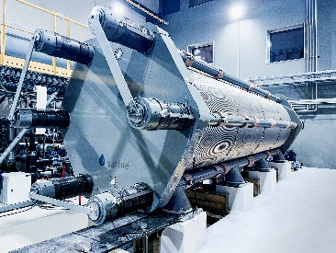
Demo4Grid Alkaline Electrolyzer: Aucotec's Engineering Base provides Sunfire with the foundation for significantly more efficient and agile plant development and clear modular engineering. (Image: Sunfire GmbH)

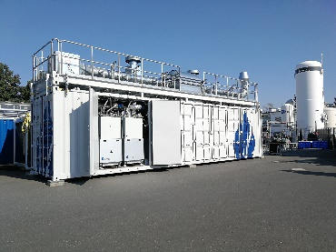
Sunfire electrolyzer: Aucotec supports electrolyzer manufacturers in increasing their capacities more quickly and exploiting their growth opportunities. (Image: Sunfire GmbH)

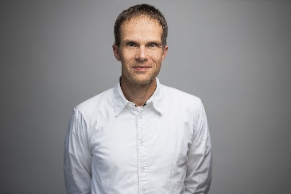
Dr. Wolfgang Staroske, Director of Project Engineering at Sunfire: "The partnership with Aucotec will help to produce green hydrogen on a large scale and promote profitable business models for an increasingly sustainable world." (Image: Sunfire GmbH)

*These images are protected by copyright. Editorial use free of charge is permitted in connection with this press release. All photographs are otherwise subject to the terms and conditions of their respective owners.

*These images are protected by copyright. They may be used for editorial purposes in connection with Aucotec.
_______________________________________________________________________
Aucotec AG has more than 35 years’ experience in the development of engineering software designed for use throughout the life cycle of machinery, plant equipment and mobile systems. Solutions range from flow diagrams and process-control/electrical technology for large-scale plant systems to modular on-board power supply units designed for the automotive industry. Software supplied by Aucotec is currently in operation throughout the world. In addition to the headquarters near Hanover, the Aucotec Group includes six other locations in Germany as well as subsidiaries in China, India, Malaysia, South Korea, the Netherlands, France, Italy, Austria, Poland, Sweden, Norway and the USA. What is more, a global partner network ensures local support all over the world.

Sunfire GmbH is a global leader in the field of hydrogen technologies and was founded in 2010. The company has produced numerous technological innovations in the electrolysis and hydrogen sector and is one of the most innovative cleantech companies in the world (member of the Global Cleantech 100 Hall of Fame). The company relies on innovative high-temperature SOEC electrolyzers and pressurized alkali technology for the sustainable transformation of energy-intensive sectors such as the chemical, fuel and steel industries.

We would be grateful if you could supply us with a copy of your article. Thank you very much!

AUCOTEC AG, Hannoversche Straße 105, 30916 Isernhagen, www.aucotec.com
Press and Public Relations, Johanna Kiesel(johanna.kiesel@aucotec.com,+49(0)511-6103186)

